**Project Overview**

**Project Title**

Mathematical Modeling for Stock Price Prediction and Portfolio Optimization Using UK Daily Historical Stock Market Data (1988-2024)

**Short Summary of the Project Topic and Background**

A general idea about the project's subject and context. This research goes towards developing a mathematical model for predicting stock prices and optimal portfolios based on daily historical stock market data generated in the UK. Implementation of complicated machine learning algorithms and models of time series analysis and econometrics shall make the program more precise for stock price predictions and ideal asset allocation. The research allows proper evaluation of models under various possible market conditions which include both financial crises and economic booms, from 1988 to 2024.

**Research Question**

How does one enable the mathematical modeling techniques involved to forecast stock values and optimize portfolios using the daily historical stock market from the UK for the years 1988 to 2024?

**Project Objectives**

1. Collect British historical stock market data and clean it.
2. Apply machine learning and statistical tools to predict stock returns.
3. Compare the performance of several predictive models.
4. Develop a rationalized portfolio plan based on expected returns and risk control concepts.
5. Back test how well the recommended plan works through back testing methods.

**Reference List**

(A list of academic papers, books, and online resources that support the research, to be added later.)

**Project Plan: Task List and/or Project Timeline**

| **Task Number** | **Task Description** | **Start Date** | **End Date** | **Notes** |
| --- | --- | --- | --- | --- |
| 1 | Data collection and preprocessing | 02/08/2025 | 02/12/2025 | Include cleaning missing values and handling anomalies |
| 2 | Exploratory Data Analysis (EDA) | 02/11/2025 | 03/05/2025 | Statistical summaries, visualizations |
| 3 | Model selection and baseline implementation | 02/20/2025 | 03/08/2025 | Compare statistical, ML, and deep learning approaches |
| 4 | Feature engineering and model tuning | 02/20/2025 | 03/08/2025 | Selecting relevant features for improved accuracy |
| 5 | Model training | 03/2/2025 | 03/28/2025 | Implementing Markowitz, Black-Litterman, or other approaches |
| 6 | Model evaluation and backtesting | 03/25/2025 | 04/02/2025 | Assess performance using financial metrics |
| 7 | Documentation and report writing | 03/15/2025 | 04/28/2025 | Compile results into a research paper/report |

**Gantt chart:**

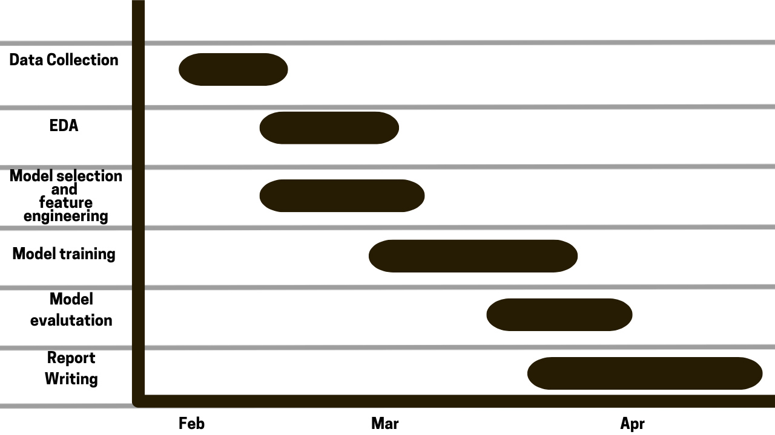

**Assessment Due Dates and Preparation Activities**

**Data Management Plan**

**Overview of the Dataset**

The database contains daily historical stock data for companies listed in the UK from the years 1988 to 2024. It contains trade volume, close, low, high, open prices, and modified close values from 1988 until 2024.

**Data Collection**

Sources Information is sourced through financial databases such as Bloomberg and Yahoo-Finance. Data extraction occurs either through scraping web pages, or by API-based extraction methods.

**Metadata**

* **Data Format:** CSV, JSON form, SQL database
* **Variables:** date, stock, definition, close, high, low, volume, market capitalization, and joining date.
* **Update Frequency:** Its static but already coming updated to be in line with 2024 data, quality sources have struck a high note.

**Document Control**

Versioning will be kept on record using either GitHub or a private cloud-based repository so that all the changes can be traced.

**Security and Storage**

* Safeguard data by encrypting it for storage in a secure cloud.
* Data will not generally be available to unauthorized people.
* Data will be prevented from loss through backups.

**Ethical Requirements**

1. **Does the Data Fall Within the Scope of GDPR?**  
   Any personal or sensitive financial information needs to comply with the GDPR, but generally, market data alone is not under GDPR unless human related.
2. **Is the Study Conforming with the Ethics of UH?**  
   The study proposed would additionally conform with all the ethical standards by the University of Hertfordshire, which also includes transparency, data privacy, and responsible artificial intelligence use.
3. **May you use the information for your proposed study?**  
   No additional permission is required for publicly accessible financial database data. For proprietary data, permission will be requested.
4. **Are you sure that the data is collected in the right way?**  
   The data is by credible source of finance and legally procedures ethically collected and disseminated.